Operational Amplifiers

Ideal Operational Amplifier

As well as resistors and capacitors, Operational Amplifiers, or Op-amps as they are more commonly called, are one of the basic building blocks of Analogue Electronic Circuits. It is a linear device that has all the properties required for nearly ideal DC amplification and is used extensively in signal conditioning, filtering or to perform mathematical operations such as add, subtract, integration and differentiation. An ideal operational amplifier is basically a 3-terminal device that consists of two high impedance inputs, one an Inverting input marked with a negative sign, ("-") and the other a Non-inverting input marked with a positive plus sign ("+").

The amplified output signal of an Operational Amplifier is the difference between the two signals being applied to the two inputs. In other words the output signal is a differential signal between the two inputs and the input stage of an Operational Amplifier is in fact a differential amplifier as shown below.

Differential Amplifier

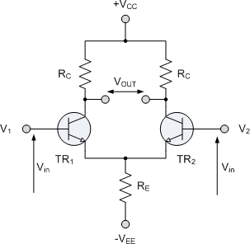
The circuit shows a generalized form of a differential amplifier with two inputs marked V₁ and V₂. The two identical transistors TR₁ and TR₂ are both biased at the same operating point with their emitters connected together and returned to the common rail, -V_{EE} by way of resistor R_{E}. The circuit operates from a dual supply +V_{CC} and -V_{EE} which ensures a constant supply. As the two base inputs are out of phase with each other, the output voltage, V_{OUT}, is the difference between the two input signals. So, as the forward bias of transistor TR₁ is increased, the forward bias of transistor TR₂ is reduced and vice versa. Then if the two transistors are perfectly matched, the current flowing through the common emitter resistor, R_{E} will remain constant.

Ideal Operational Amplifiers have an output of low impedance that is referenced to a common ground terminal and it should ignore any common mode signals. That means, if identical signals are applied to both the inverting and non-inverting inputs there should be no change at the output. However, in real amplifiers there is always some variation and the ratio of the change to the output voltage with regards to the change in the common mode input voltage is called the Common Mode Rejection Ratio or CMRR.
Operational Amplifiers have a very high open loop DC gain, commonly known as the Open Loop Differential Gain, and is given the symbol (A_{o}). By applying some form of Negative Feedback we can produce an operational amplifier circuit with a very precise gain characteristic that is dependent only on the feedback used. An operational amplifier only responds to the difference between the voltages at its two input terminals, known commonly as the "Differential Input Voltage" and not to their common potential. Then if the same voltage potential is applied to both terminals the resultant output will be zero.
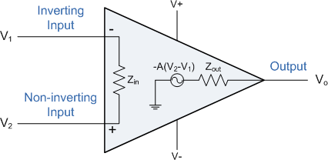
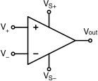

Symbol of OpAmp Equivalent Circuit for Ideal OpAmp

Idealized Characteristics

PARAMETER IDEALIZED CHARACTERISTIC
Voltage Gain, (A) Infinite - The main function of an operational amplifier is to
amplify the input signal and the more open loop gain it has the better, so for an ideal amplifier the gain will be infinite.

Input impedance, (Z_{in}) Infinite - Input impedance is assumed to be infinite to
prevent any current flowing from the source supply into the amplifiers input circuitry.

Output impedance, (Z_{out}) Zero - The output impedance of the ideal operational
amplifier is assumed to be zero so that it can supply as much current as necessary to the load.

Bandwidth, (BW) Infinite - An ideal operational amplifier has an infinite
Frequency Response and can amplify any frequency signal so it is assumed to have an infinite bandwidth.

Offset Voltage, (V_{io}) Zero - The amplifiers output will be zero when the voltage
difference between the inverting and non-inverting inputs is zero.
It is important to remember two properties known as the golden rules, as they help understand the working of the amplifier with regards to analysis and design of operational amplifier circuits.
- No current flows into either input terminal (the current rule)
- The differential input offset voltage is zero (the voltage rule).

However, real Operational Amplifiers (e.g. 741) do not have infinite gain or bandwidth but have a typical "Open Loop Gain" which is defined as the amplifiers output amplification without any external feedback signals connected to it and for a typical operational amplifier is about 100dB at DC (zero Hz). This output gain decreases linearly with frequency down to "Unity Gain" or 1, at about 1MHz and this is shown in the following open loop gain response curve. From this frequency response curve we can see that the product of the gain against frequency is constant at any point along the curve. Also that the unity gain (0dB) frequency also determines the gain of the amplifier at any point along the curve. This constant is generally known as the Gain Bandwidth Product or GBP.
Therefore, GBP = Gain × Bandwidth or A × BW.

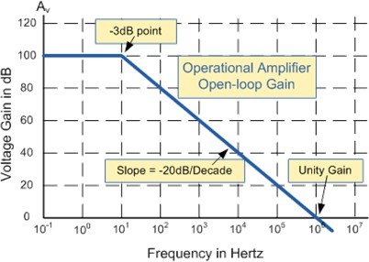
Open-loop Frequency Response Curve
For example, from the graph above the gain of the amplifier at 100kHz = 20dB or 10, then the GBP = 100,000Hz x 10 = 1,000,000.
Similarly, a gain at 1kHz = 60dB or 1000, therefore the GBP = 1,000 x 1,000 = 1,000,000. The same!.

The Voltage Gain (A) of the amplifier can be found using the following formula:
Gain, A = Vo
Vi
and in Decibels or (dB) is given as:

20 log A = 20 log Vo
Vi

Bandwidth of Operational Amplifier
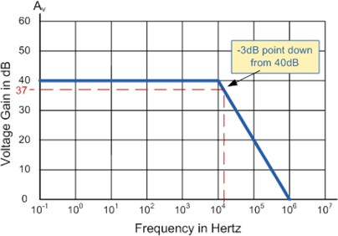

The operational amplifiers bandwidth is the frequency range over which the voltage gain of the amplifier is above 70.7% or -3dB (where 0dB is the maximum) of its maximum output value as shown below.
Here we have used the 40dB line as an example. The -3dB or 70.7% of V_{max} down point from the frequency response curve is given as 37dB. Taking a line across until it intersects with the main GBP curve gives us a frequency point just above the 10kHz line at about 12 to 15kHz. We can now calculate this more accurately as we already know the GBP of the amplifier, in this particular case 1MHz.

Example No1.
Using the formula 20 log (A), we can calculate the bandwidth of the amplifier as: 37 = 20 log A therefore, A = anti-log (37 ÷ 20) = 70.8
GBP ÷ A = Bandwidth, therefore, 1,000,000 ÷ 70.8 = 14.124Hz, or 14kHz
Then the bandwidth of the amplifier at a gain of 40dB is given as 14kHz as predicted from the graph.

Example No2.
If the gain of the operational amplifier was reduced by half to say 20dB in the above frequency response curve, the -3dB point would now be at 17dB. This would then give us an overall gain of 7.08, therefore A = 7.08. If we use the same formula as above this new gain would give us a bandwidth of 141.2kHz, ten times more than at 40dB.

It can therefore be seen that by reducing the overall open loop gain of an operational amplifier its bandwidth is increased and vice versa. The -3dB point is also known as the "half power point", as the output power of the amplifier is at half its maximum value at this point.

Op-amp types

Operational amplifiers can be connected using external resistors or capacitors in a number of different ways to form basic "Building Block" circuits such as, Inverting, Non- Inverting, Voltage Follower, Summing, Differential, Integrator and Differentiator type amplifiers. There are a very large number of operational amplifier IC's available to suit every possible application.
The most commonly available and used of all operational amplifiers is the industry standard 741
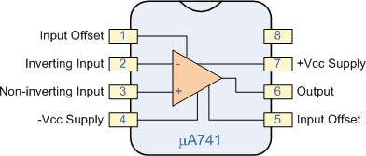
type IC.

Inverting Amplifier

The open loop gain of an ideal Operational Amplifier can be very high, up to about 1,000,000 (120dB) or more. However, this very high gain is of no real use to us as it makes the amplifier both unstable and hard to control as the smallest of input signals, just a few micro- volts, would be enough to cause the output to saturate and swing towards one or the other of the voltage supply rails losing control. As the open loop DC gain of an operational amplifier is extremely high we can afford to lose some of this gain by connecting a suitable resistor across the amplifier from the output terminal back to the inverting input terminal to both reduce and control the overall gain of the amplifier. This then produces an effect known commonly as Negative Feedback, and thus produces a very stable Operational Amplifier system.

Negative Feedback is the process of "feeding back" some of the output signal back to the input, but to make the feedback negative we must feed it back to the "Negative input" terminal using an external Feedback Resistor called R_{f}. This feedback connection between the output and the inverting input terminal produces a closed loop circuit to the amplifier resulting in the gain of the amplifier now being called its Closed-loop Gain.

This results in the inverting input terminal having a different signal on it than the actual input voltage as it will be the sum of the input voltage plus the negative feedback voltage giving it the label or term of a Summing Point. We must therefore separate the real input signal from the inverting input by using an Input Resistor, R_{in}. As we are not using the positive non-inverting input this is connected to a common ground or zero voltage terminal as shown below. But the effect of this closed loop feedback circuit results in the voltage at the inverting input equal to that at the non-inverting input producing a Virtual Earth summing point because it will be at the same potential as the grounded reference input.

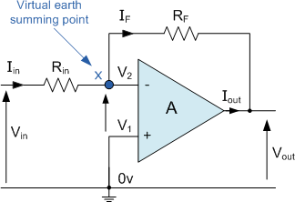
Inverting Amplifier Circuit
In inverting amplifier circuit the operational amplifier is connected with feedback to produce a closed loop operation. There are two very important rules to remember about inverting amplifiers: "no current flows into the input terminal" and that "V₁ equals V₂". This is because the junction of the input and feedback signal (X) is at the same potential as the positive (+) input which is at zero volts or ground then, the junction is a "Virtual Earth". Because of this virtual earth node the input resistance of the amplifier is equal to the value of the input resistor, R_{in}. Then by using these two rules one can find the equation for calculating the gain of an inverting amplifier, using first principles.
Current ( i ) flows through the resistor network as shown.

i = Vin
Rin
= − Vo
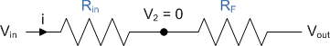
R f

The negative sign in the equation indicates an inversion of the output signal with respect to the input as it is 180º out of phase. This is due to the feedback being negative in value.
Then, the Closed-Loop Voltage Gain of an Inverting Amplifier is given as.

Example No1
Gain = Vo
Vin
= − Rf
Rin

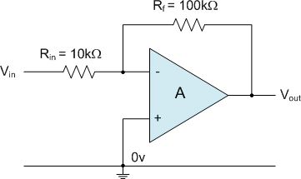
Find the closed loop gain of the given inverting amplifier circuit.

Using the previously found formula for the gain of the circuit

Gain = Vo
Vin
= − Rf
Rin

R_{in} = 10kΩ and R_{f} = 100kΩ. Gain = -R_{f}/R_{in} = 100k/10k = 10.
Therefore, the closed loop gain of the given inverting amplifier circuit is given 10 or 20dB.

Example No2.
The gain of the original circuit is to be increased to 40, find the new values of the resistors required.
Assume that the input resistor is to remain at the same value of 10KΩ, then by re-arranging the closed loop voltage gain formula we can find the new value required for the feedback resistor R_{f}. Gain = -R_{f}/R_{in}
So, R_{f} = Gain x R_{in}
Rf = 400,000 or 400KΩ
The new values of resistors required for the circuit to have a gain of 40 would be, R_{in} = 10KΩ and R_{f} = 400KΩ.
The formula could also be rearranged to give a new value of R_{in}, keeping the same value of R_{f}.

Unity Gain Inverter
One final point to note about Inverting Amplifiers, if the two resistors are of equal value, R_{in} = R_{f} then the gain of the amplifier will be -1 producing a complementary form of the input voltage at its output as V_{out} = -V_{in}. This type of inverting amplifier configuration is generally called a Unity Gain Inverter of simply an Inverting Buffer.

Non-inverting Amplifier

The second basic configuration of an operational amplifier circuit is that of a Non- inverting Amplifier. In this configuration, the input voltage signal, (V_{in}) is applied directly to the Non-inverting (+) input terminal which means that the output gain of the amplifier becomes "Positive" in value in contrast to the "Inverting Amplifier" circuit whose output gain is negative in value. Feedback control of the non-inverting amplifier is achieved by applying a small part of the output voltage signal back to the inverting (-) input terminal via a R_{f} - R₂ voltage divider network, again producing negative feedback. This produces a Non-inverting Amplifier circuit with very good stability, a very high input impedance, R_{in} approaching infinity (as no current flows into the positive input terminal) and a low output impedance, r_{out} as shown below.

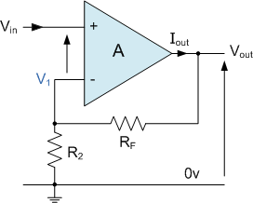
Non-inverting Amplifier Circuit

Since no current flows into the input of the amplifier, V₁ = V_{in}. In other words the junction is a "Virtual Earth" summing point. Because of this virtual earth node, the resistors R_{f}
and R₂ form a simple voltage divider network across the amplifier and the voltage gain of the circuit is determined by the ratios of R₂ and R_{f} as shown below.

Equivalent Voltage Divider Network
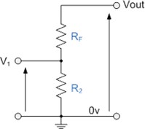
Then using the formula to calculate the output voltage of a potential divider network, we can calculate the output Voltage Gain of the Non-inverting Amplifier as:

V0 = Vin
(1 + Rf )
R

Gain = Vo
Vin
2
= 1 + Rf
R2

We can see that the overall gain of a Non-Inverting Amplifier is greater but never less than 1, is positive and is determined by the
ratio of the values of R_{f} and R₂. If the feedback resistor R_{f} is zero the gain will be equal to 1, and if resistor R₂ is zero the gain will approach infinity, but in practice it will be limited to the operational amplifiers open-loop differential gain, (A_{o}).

Voltage Follower (Unity Gain Buffer)

If we made the feedback resistor, R_{f} = 0 then the circuit will have a fixed gain of "1" and would be classed as a Voltage Follower. As the input signal is connected directly to the non- inverting input of the amplifier the output signal is not inverted resulting in the output voltage being equal to the input voltage, V_{out} = V_{in}. This then makes the Voltage Follower circuit ideal as a Unity Gain Buffer circuit because of its isolation properties as impedance or circuit isolation is more important than amplification. The input impedance of the voltage follower circuit is very high, typically above 1MΩ.
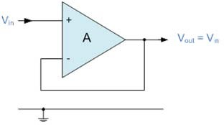

In this circuit, R_{in} has increased to infinity and R_{f} reduced to zero, the feedback is 100% and V_{out} is exactly equal to V_{in} giving it a fixed gain of 1 or unity. As the input voltage V_{in} is applied to the non-inverting input the gain of the amplifier is given as:
Vo = A(Vin − Vo )

Vin = V+
Gain = Vo
Vo = V−

= 1

Vin

The voltage follower or unity gain buffer is a special and very useful type of Non- inverting amplifier circuit that is commonly used in electronics to isolate circuits from each other especially in High-order state variable or Sallen-Key type active filters to separate one filter stage from the other. Typical digital buffer IC's available are the 74LS125 Quad 3-state buffer or the more common 74LS244 Octal buffer.
One final thought, the output voltage gain of the voltage follower circuit with closed loop gain is Unity, the voltage gain of an ideal operational amplifier with open loop gain (no feedback) is infinite. Then by carefully selecting the feedback components we can control the amount of gain produced by an Operational Amplifier anywhere from 1 to infinity.

Differential Amplifier

Up to now we have used only one input to connect to the amplifier, using either the "Inverting" or the "Non-inverting" input terminal to amplify a single input signal with the other input being connected to ground. But we can also connect signals to both of the inputs at the same time producing another common type of operational amplifier circuit called a differential amplifier.
The resultant output voltage will be proportional to the "Difference" between the two input signals, V₁ and V₂. This type of circuit can also be used as a subtractor.

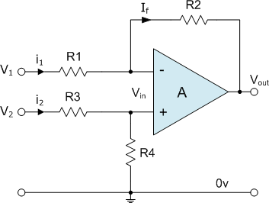
Differential Amplifier Circuit

The transfer function for a differential amplifier circuit is given as:
V = − R2 V + (1 + R2 )( R4 )V
1
o
2

1 R1
R
R3 + R4

When R1 = R3 and R2 = R4 the transfer function formula can be modified to the following:

Vo =
R2 (V R1
− V1 )

If all the resistors are all of the same ohmic value the circuit will become a Unity Gain Differential Amplifier and the gain of the amplifier will be 1 or Unity.
2

One major limitation of this type of amplifier design is that its input impedances are lower compared to that of other operational amplifier configurations, for example, a non- inverting (single-ended input) amplifier. Each input voltage source has to drive current through an input resistance, which has less overall impedance than that of the op-amps input alone. One way to overcome this problem is to add a Unity Gain Buffer Amplifier such as the voltage follower seen in the previous tutorial to each input resistor. This then gives us a differential amplifier circuit with very high input impedance and is the basis for most "Instrumentation Amplifiers", mainly used to amplify very small differential signals from strain gauges, thermocouples or current sensing resistors in motor control systems.

